**TUGAS**

**PEMROGRAMAN KOMPUTER 2**

“STRUCT”



KELOMPOK 7:

Ivan Andri Wahhyudi (203510197)

Iqbal Maulana (203510206)

Supian (203510241)

Gunawan (203510173)

**PROGRAM STUDI INFORMATIKA**

**FAKULTAS TEKNIK**

**UNIVERSITAS ISLAM RIAU**

**2021/2022**

1. Kasus

Menghitunng Nilai Akhir Mahasiswa

1. Coding

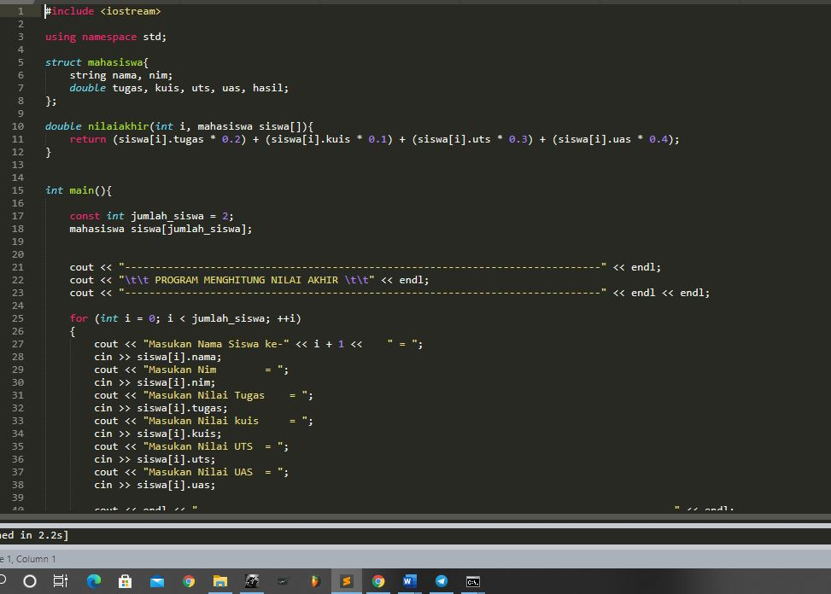

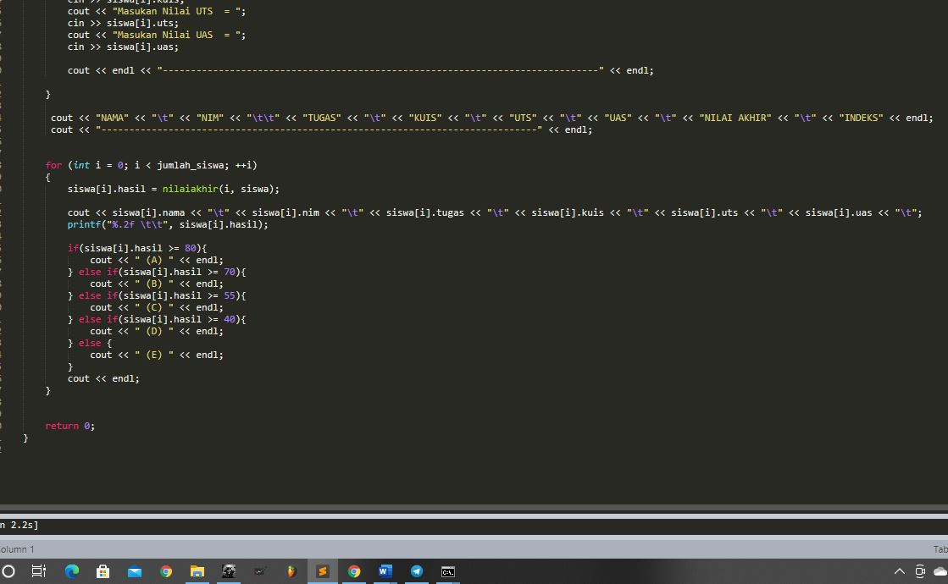

#include <iostream>

using namespace std;

struct mahasiswa{

string nama, nim;

double tugas, kuis, uts, uas, hasil;

};

double nilaiakhir(int i, mahasiswa siswa[]){

return (siswa[i].tugas * 0.2) + (siswa[i].kuis * 0.1) + (siswa[i].uts * 0.3) + (siswa[i].uas * 0.4);

}

int main(){

const int jumlah_siswa = 2;

mahasiswa siswa[jumlah_siswa];

cout << "------------------------------------------------------------------------------" << endl;

cout << "\t\t PROGRAM MENGHITUNG NILAI AKHIR \t\t" << endl;

cout << "------------------------------------------------------------------------------" << endl << endl;

for (int i = 0; i < jumlah_siswa; ++i)

{

cout << "Masukan Nama Siswa ke-" << i + 1 << " = ";

cin >> siswa[i].nama;

cout << "Masukan Nim = ";

cin >> siswa[i].nim;

cout << "Masukan Nilai Tugas = ";

cin >> siswa[i].tugas;

cout << "Masukan Nilai kuis = ";

cin >> siswa[i].kuis;

cout << "Masukan Nilai UTS = ";

cin >> siswa[i].uts;

cout << "Masukan Nilai UAS = ";

cin >> siswa[i].uas;

cout << endl << "------------------------------------------------------------------------------" << endl;

}

cout << "NAMA" << "\t" << "NIM" << "\t\t" << "TUGAS" << "\t" << "KUIS" << "\t" << "UTS" << "\t" << "UAS" << "\t" << "NILAI AKHIR" << "\t" << "INDEKS" << endl;

cout << "------------------------------------------------------------------------------" << endl;

for (int i = 0; i < jumlah_siswa; ++i)

{

siswa[i].hasil = nilaiakhir(i, siswa);

cout << siswa[i].nama << "\t" << siswa[i].nim << "\t" << siswa[i].tugas << "\t" << siswa[i].kuis << "\t" << siswa[i].uts << "\t" << siswa[i].uas << "\t";

printf("%.2f \t\t", siswa[i].hasil);

if(siswa[i].hasil >= 80){

cout << " (A) " << endl;

} else if(siswa[i].hasil >= 70){

cout << " (B) " << endl;

} else if(siswa[i].hasil >= 55){

cout << " (C) " << endl;

} else if(siswa[i].hasil >= 40){

cout << " (D) " << endl;

} else {

cout << " (E) " << endl;

}

cout << endl;

}

return 0;

}

1. hasil running program

